

MSc Data Science Project
7PAM2002-0901-2025
Department of Physics, Astronomy and Mathematics

Data Science FINAL PROJECT REPORT

Project Title: Comparative Analysis of Logistic Regression, Random Forest, and Deep Neural Networks for Diabetes Prediction

Student Name: Ganesh Avirni
SRN: 23092755
Supervised by: Vandana das
GitHub Repo: https://github.com/avirni5259/medical-no-show.git
Table of Contents
Abstract 3
Acknowledgements 3
Chapter 1: Introduction 4
Overview 4
Problem Statement 4
Research Question 4
Objectives 5
Chapter 2: Background 6
Dataset 6
Literature Review 6
Paper I 6
Paper II 7
Paper III 7
Paper IV 7
Research Gap 7
Algorithms 8
Logistic Regression 8
XGBoost 8
CatBoost 8
Artificial Neural Network 8
Chapter 3: Methodology 9
Tools and Techniques 9
EDA and Visualization 9
Chapter 4: Results and Conclusion 18
Results 18
Critical Discussion 18
Conclusion 19
Future Work 19
Chapter 5: Legal, Ethical and Professional Issues 20
References 20
Appendices 21

Abstract
Losses of medical appointments are costly to health facilities in terms of operations and clinical effects. In this research, I examine the performance of XGBoost, CatBoost, and Deep Neural Networks (DNNs) in terms of predicting patient no-shows based on a big, real-life dataset of a Brazilian rehabilitation facility. Models are also tested with focus on recall because there is severe imbalance of classes. Findings indicate that tree-based models can be highly accurate, but the DNN can significantly be more effective than tree-based models in recall, and find more than half of no-show cases. The results indicate the significance of the metric choice and prove the usefulness of neural networks in the area of proactive intervention in healthcare scheduling.

Acknowledgements
Every person and the academic context in which the project was created facilitated making this project possible. I would also like to acknowledge the instructions and feedback I could get during the process of conducting the research, which contributed to shaping my ideas and making the work high-quality. The educational assistance offered at the various phases of the project also played a significant role in keeping the project on track and focus.
I would also like to mention that the University of Hertfordshire provided a conducive learning environment and unlimited access to necessary resources that made it possible to conduct this research successfully. The implementation of the teaching and assessment process was highly organized, and this played a great role in successful completion of the project.
I also want to thank my colleagues as I enjoyed collaborating with them and having an opportunity to discuss different matters with them. Lastly, I would like to thank my relatives, friends, and family members who remained encouraging, patient and motivated during this process.

Chapter 1: Introduction

Overview
Healthcare systems worldwide face persistent challenges related to patient appointment no-shows, which disrupt clinical workflows, waste resources, and compromise patient outcomes. Missed appointments lead to inefficient staff allocation, longer waiting lists, and delayed care for individuals with chronic or rehabilitative needs. With the increasing digitalization of health records, predictive modelling has become a promising solution for identifying patients most at risk of missing scheduled visits. This project focuses on developing machine-learning models—specifically XGBoost, CatBoost, and Deep Neural Networks—to analyse demographic, clinical, scheduling, and environmental factors associated with attendance behaviour. By leveraging a large, multi-year dataset from a Brazilian rehabilitation clinic, the study aims to evaluate the relative performance of these algorithms and determine which method offers the most accurate prediction of no-show events.

Problem Statement
Miss attendance at appointments in healthcare systems is a major issue, which leads to inefficiency, resource distribution inefficiency, and patient waiting time (Kler et al., 2024). Cancellation of appointments does not only derail the clinic schedules but also has negative outcomes to the patient as subsequent appointments are vital in the management of chronic conditions and the rehabilitation programmes. One of the ways to eliminate nonattendance is predictive modelling, which allows healthcare providers to predict which patients are not likely to attend an appointment and thus allows the automated administration of such interventions as the use of automated reminders, rebooking, or the use of a specific patient engagement strategy (Deina et al., 2024).
The data used in this research is obtained within the Brazilian national healthcare and entails anonymised patient appointment data, such as demographic, scheduling and health related data (Chen et al., 2021). Attributes include the age of the patients, their gender, the date and time of the appointment, the waiting time between appointment and scheduling, type of medical care and the history of their no-shows, and climate like weather conditions. This type of detailed data allows the analysis of trends that lead to the absence of appointments, which improves the possibility of achieving a predictive value.
Gradient-boosting models, including XGBoost and CatBoost, have shown good results on tabular data when it comes to healthcare prediction tasks (AlSerkal et al., 2025). These models are effective at managing categorical variables, imbalanced data and interaction of features thus making them applicable to no-show prediction. Similarly, Deep Neural Networks (DNNs) offer the ability to model complex non-linear interactions between features that can identify latent relationships within patient behaviour which tree-based approaches may fail to identify. Through such comparisons, this project aims at establishing the best predictive model and discussing such important features as they affect attendance of appointments.
Finally, the results of this research may help healthcare professionals lower the rate of no-shows, better clinic scheduling, resource optimization, and improve patient outcomes. The project, in its turn, adds to the overall body of work on predictive analytics in healthcare and illustrates how complex machine-learning methods can be applied to practical operational issues (AlSerkal et al., 2025; Deina et al., 2024).

Research Question
Can a Deep Neural Network outperform XGBoost and CatBoost in predicting patient no-shows using demographic and scheduling data?

Objectives
Primary Objective:
- To develop and compare the performance of XGBoost, CAT Boost, and Deep Neural Networks in predicting medical appointment attendance.
Secondary Objectives:
- To identify the most influential features affecting patient no-show behaviour.
- To evaluate the impact of data preprocessing and feature engineering on model performance.
- To provide actionable insights for healthcare providers to reduce no-show rates.

Chapter 2: Background

Dataset
The data applied in this project is sourced on the Center of Specialization in Physical and Intellectual Rehabilitation (CER) in Southern Brazil which belongs to the Brazilian Unified Health System (SUS). It consists of 49,593 anonymized records of medical appointments between 2016 and 2022 and provides an in-depth analysis of the attendance behaviour in a rehabilitation-centred outpatient clinic. The institution works with physically, cognitively, and developmentally challenged patients to offer the provision of long-term therapeutic services and psychosocial assistance. Since most patients have to visit the health facility regularly, attendance prediction is essential to make continuity of care and efficient resource distribution possible.
The data has a wide range of features in terms of demographics, clinical, scheduling, and contextual aspects. Demographic data includes age, gender, type of disability, and a necessity to have someone with them-factors that are known to affect the access to healthcare. Attributes related to the appointment comprise of specialty, the date and time of the appointment, the shift, waiting period and documented reasons why the appointment was not attended. Health-related information including ICD diagnostic codes is useful to put into perspective the nature and the extent of conditions treated. Moreover, the data combines the environmental factors such as temperature, rain, storms and heat intensity which will enable evaluation of whether the external factors affect patient behaviour.
The analysis is further enriched with derived features such as age-based categories, date of service entry etc. The dependent variable, which is "no-show," is used to show whether a patient rightly attended an appointment or not. The breadth of the dataset can be used to build strong predictive models as well as address behavioural patterns in a more profound way. Its combination of clinical and environmental variables is also suitable to test more sophisticated machine-learning techniques, as well as determine their capability to extract complex interaction behind attendance outcomes.

Literature Review

Paper I
The issue of patient no-shows, which remains highly persistent in healthcare, is discussed by Kler et al. (2024), and supervised machine-learning methods are suggested to serve as the solution. The study uses a large Brazilian outpatient appointment dataset, which is not the case with previous research, which relies primarily on descriptive statistics or heuristic rules. The authors contextualize no-shows as a managerial problem, which raises expenses, wastage of resources, and waiting time, and as such, this justifies precise predictive models.
The paper has a typical yet efficient machine-learning pipeline of tabular healthcare data, such as imputation, one-hot encoding, and feature scaling. XGBoost is chosen as the key model because it can address the non-linear relationships and class imbalance, which are major in the patient attendance behavior. Instead of using external methods of resampling, the authors adjust the scaleposweight parameter in order to enhance minority-class detection. The model has a recall of about 65 to no-shows, which is better than the baseline techniques that are usually discussed in the literature. Age, SMS reminders, and history of no-shows are much more likely to be of particular importance to the analysis, which feature importance analysis confirms that this has been found to be true previously. The practical value of the paper is its actionable information, especially on the topics of targeted reminders and patient engagement strategies. Nevertheless, only one algorithm is analyzed and not much effort is done to investigate feature interactions beyond ranked importance leaving room to consider other models and further investigate the interactions.

Paper II
Toffaha et al. reduce the interest of no-show prediction on pure performance to interpretability, stating that transparency and trust are vital in healthcare environments with high stakes. The paper analyzes four types of interpretable models, namely, rule sets, rule lists, rule trees and algebraic models, on a large Brazilian outpatient dataset. The taxonomy offers conceptual understanding and facilitates any significant comparison between interpretability paradigms.
The approach is very stringent, involving a lot of feature engineering, Recursive Feature Elimination, balanced sampling solution (ROS and RUS), nested cross-validation, and statistical significance testing. The findings indicate that models like FIGS and Tree-GAM yield good F1-scores and are also interpretable. Clinically meaningful interactions are found by qualitative analysis of model structures, including between lead time and age and previous no-shows. The paper is particularly topical as a response to the black-box optimization, which underlines the significant role of deployable and explainable models and high recall in the general healthcare.

Paper III
Abushaaban and Agaoglu offer a thoroughly rigorous study of the medical appointment no-show prediction, in which they consider class imbalance instead of a novelty of the algorithm. The paper presents no-show prediction as a problem of data asymmetry and evaluation due to the influence of healthcare strain, which has been magnified during the COVID-19. Its primary value lies in systematic comparison of three imbalance-Handling paradigms, namely data-level resampling, algorithm-level modification and cost-Sensitive learning. The authors compare a great number of under-, over-, and hybrid sampling methods (e.g. RUS, SMOTE, ADASYN, SMOTETomek) on a variety of classifiers including Random Forests, SVMs, ANNs, Decision Trees and Naive Bayes. It has been found that performance is not only a matter of the balancing strategy, but also a matter of the classifier itself. The study is further strengthened by feature engineering which adds the temporal and behavioral variables showing that the behavior of previous attendance is a prevailing predictor. Assessment focuses on G-mean, balanced accuracy and ROC-AUC, which does not give a false impression of raw accuracy. Random Forest with under-sampling and Balanced random Forest has the best general results whereas SVM is robust in balancing techniques. ANNs are sensitive to the distribution of classes because they only work well with appropriate over-sampling.

Paper IV
According to Lovatte et al., the key impediment in no-show prediction is class imbalance, and not model expressiveness. They compare data-level resampling and cost-sensitive learning on a set of classifiers using a very large Brazilian dataset. The drawbacks of resampling are that it enhances recall and AUC at the cost of precision, whereas cost-sensitive C4.5 can attain the performance of a competitor with little to no preprocessing. The authors emphasize the idea that the constraints of structural datasets, including the lack of attendance history, give a limit of the possible performance.

Research Gap
The literature is focused on imbalance management instead of model architecture and maximizes accuracy or AUC. Modern gradient boosting and deep neural networks have little comparison with respect to recall-oriented evaluation. This project will fill these gaps by comparing XGBoost, CatBoost, and deep neural networks through the recall-based approach.

Algorithms

Logistic Regression
The baseline model employed in this project is the Logistic Regression that gives a clear and understandable reference point when predicting medical appointment no-shows. It is a probabilistic model of a binary outcome, which employs a sigmoid function to a linear combination of input features. The parameters of the model are optimised through the minimisation of binary cross-entropy loss through gradient-based optimisation. This is because each coefficient is directly proportional to the effect of a feature on no-show likelihood, and thus the model is easy to interpret. It is restricted in its capacity to model the complex interactions in attendance behaviour though, as it has a linear decision boundary.

XGBoost
XGBoost is an ensemble gradient-boosting model that is highly appropriate with structured healthcare data. It constructs decision trees one by one and each addition of a tree rectifies error of the last ensemble based on gradient information of the loss function. The complexity of the trees is checked with regularisation terms and overfitting is discouraged. XGBoost is capable of capturing the interaction of non-linear features, and thus it is appropriate to predict no-shows that are affected by several interacting demographic and scheduling variables.

CatBoost
CatBoost is a gradient-boosting algorithm that can work with categorical variables. It applies ordered boosting and target-based encoding to avoid data leakage and lessen the expense of manual encoding. CatBoost has the ability to ensure stable performance and high generalisation through the construction of symmetric decision trees and regularisation. The characteristics of these properties allow it to be especially useful in the healthcare appointment data where most attributes are categorical.

Artificial Neural Network
The Artificial Neural Networks are a model that can give complex and non-linear relationships by use of layers of interconnected neurons. The features of the input are converted into features of the output by weighted sums and non-linear activation functions in each of the layers. The training is done through backpropagation and binary cross-entropy loss and also with Adam optimisers. The ANN in this project showed good recall of no-show prediction, which means that it is highly sensitive to trends of the minority classes, but with lower interpretability.

Chapter 3: Methodology

Tools and Techniques
The various analytical tools and machine-learning methods are incorporated in this project to construct and compare predictive models targeting medical appointment no-shows. It uses python as its foundation with extensive data manipulation, visualization, and modelling libraries. Pandas and NumPy provide fast preprocessing, such as the ability to work with missing values, the encoding of categorical variables, and the scaling of numerical data. The exploratory data analysis is performed with the help of Matplotlib and Seaborn, which aid in visualising the distribution, correlation, and categorical patterns that are essential in understanding the attendance behaviour.
In a bid to deal with a class imbalance in the variable of interest, the project applies SMOTE (Synthetic Minority Oversampling Technique) and creates artificial samples in the minority category and makes sure that the models receive a more representative pattern. Numerical variables are normalized with the help of StandardScaler, and categorical variables can be processed with one-hot encoding or automatically processed by a certain algorithm.
The modelling process involves the combination of enhanced and conventional machine-learning methods. XGBoost and CatBoost have been chosen due to their good performance with formatted tabular data and capacity to capture complex interactions. A Deep Neural Network (DNN), which is developed in Tensorflow/Keras, offers a highly adaptable architecture that is able to acquire non-linear patterns via its multilayer design. It has a Random Forest classifier which is an ensemble that is robust as a baseline.
Performance metrics used to evaluate models are accuracy, precision, recall, F1-score and ROC-AUC, and GridSearchCV can be used to systematically tune hyperparameters.
Key Techniques Used:
- Cleaning of data, normalizing and categorical encoding.
- Synthetic oversampling with SMOTE.
- Gradient-boosting models (XGBoost, CatBoost)
- Deep Neural Network and dropout regularization.
- Random Forest Ensemble modelling.
- Hyperparameter optimization with GridSearchCV.

EDA and Visualization
An exploratory data analysis phase will investigate patterns, distributions, and relationships of the dataset and allow understanding the underlying factors which might have an impact on patient attendance better. The initial process has been the analysis of the target variable, noshow.
Figure 1: No-Show Appointment Distribution
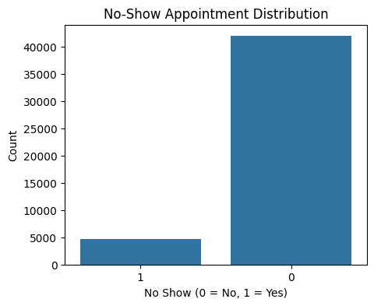
The distribution is uneven, with a much larger number of the patients reporting to their appointments in comparison to the number of patients who missed. This is a critical imbalance since the models that are being trained using such data may be biased towards the majorities, which will require subsequent use of SMOTE in order to balance the training data. Below is the image which shows the target variable after resampling.
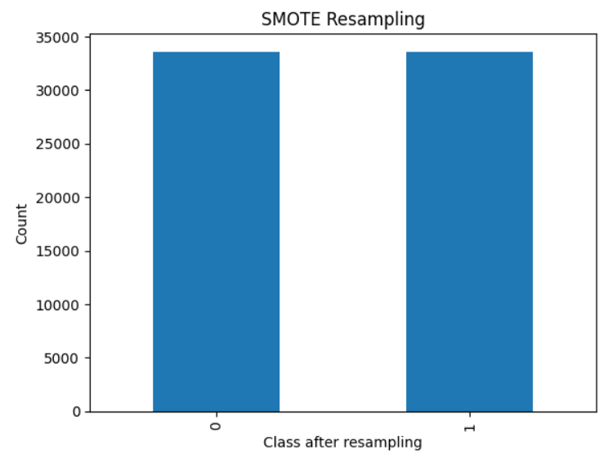
Second, the numerical feature distributions were analysed in order to investigate the demographic, clinical, and environmental features. These plots exhibit a significant difference in features like age, rainfall as well as ambient temperature.
Figure 2: Numeric Feature Distributions
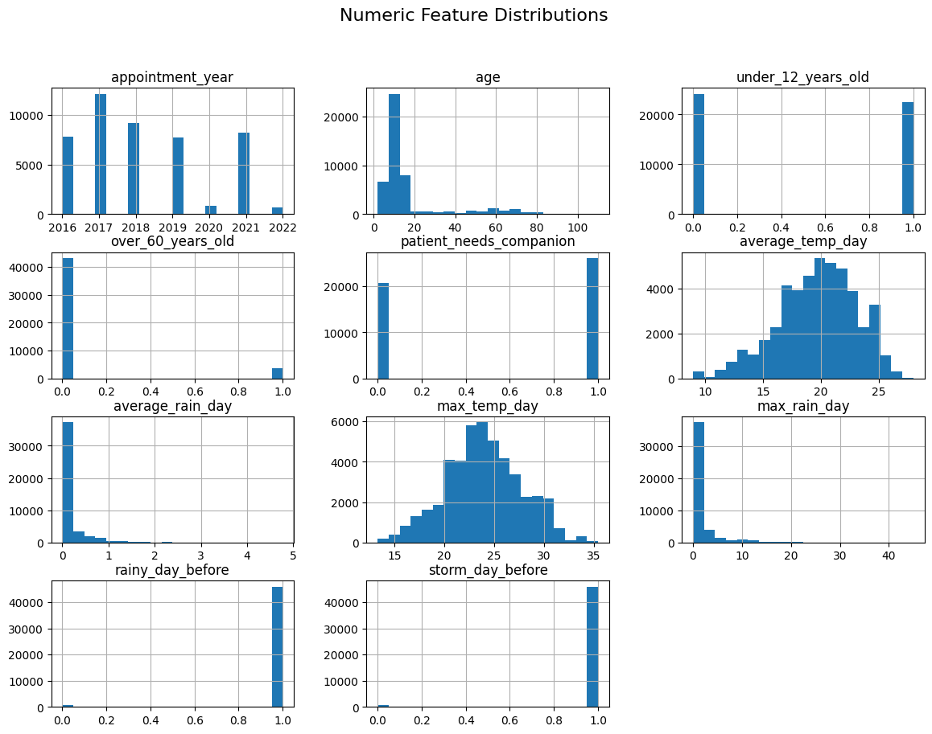

The age is almost right skewed with most patients being children or middle aged adults, with very old people as an outlier. This is reflected in binary indicators that include under12yearsold and over60yearsold. Patterns of environmental variables are expected seasonal variations: features related to temperatures are similar to normal distributions, and the characteristics of precipitation are many near-zero values, which identify mild weather conditions with some heavy rain.
Correlation analysis will give information on the linear relation between numeric variables.
Figure 3: Correlation Heatmap
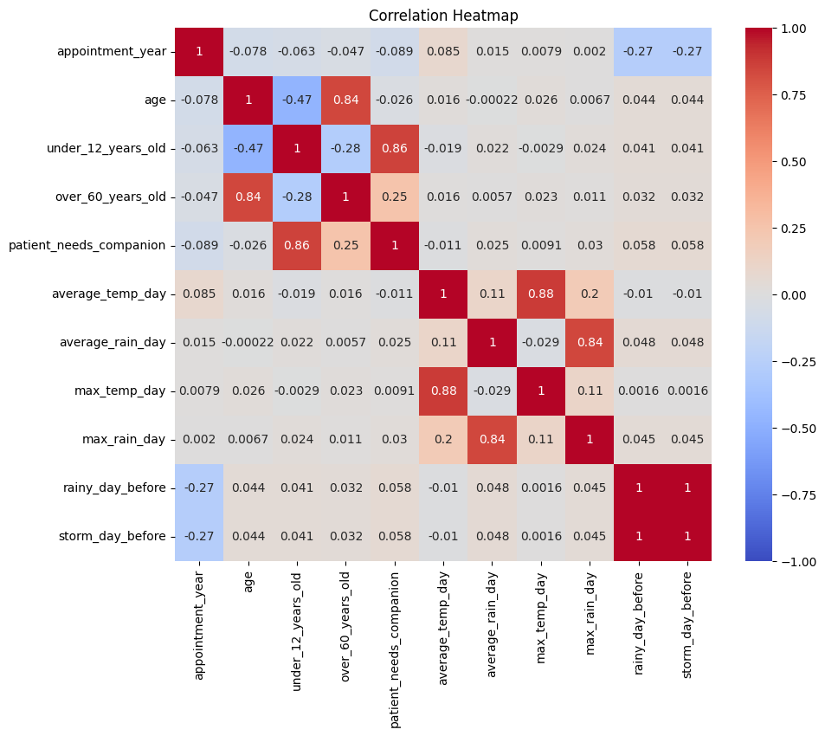
Close associations seem to exist between weather characteristics, especially between averagetmpday and max tempday, and between measures of rainfall. Nonetheless, the majority of the demographic or appointment related variables have weak correlations among themselves as well as with the result of no-show. This implies that the attendance behaviour can be conditional on the non-linear interactions that cannot be well captured using simple models such as gradient boosting or neural networks.
Categorical variables were analysed to get to know the trends of behaviours among groups of patients.
Figure 4: Specialty vs No-Show
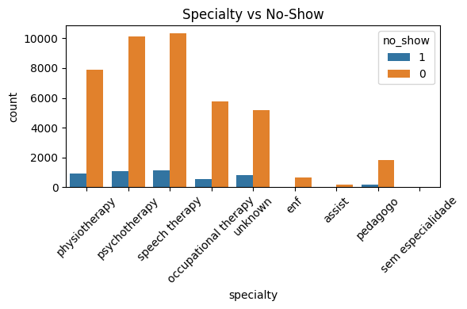
The specialty distribution reveals that large volume departments, e.g. physiotherapy and speech therapy, have the majority of the appointments, and although the majority of patients attend, no-show rates are still clinically significant. There are also similar trends with smaller departments having lower overall counts. This information can be used to determine services that are subject to specific interventions.
Figure 5: Gender vs No-Show
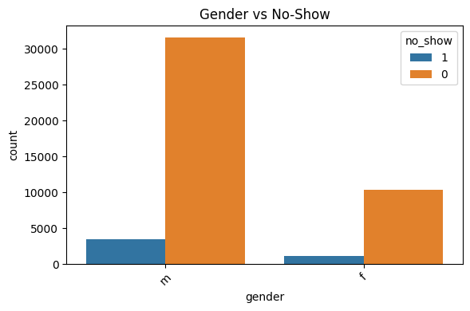
Males and females indicate significantly more attended than missed appointments, though some small proportional differences could be useful in the process of feature importance analysis.
The temporal variation is examined using the distributions of appointment months.
Figure 6: Appointment Month vs No-Show
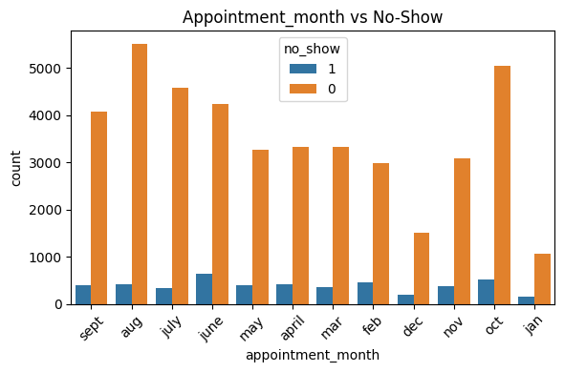
The numbers vary monthly, with the highest figures recorded in the middle years (June-August). The trends probably indicate clinic scheduling trends and seasonal patient activity as opposed to significant changes in the attendance behaviour.
Whereas, environmental categorical variables were also compared with no show.
Figure 7: Rain Intensity vs No-Show
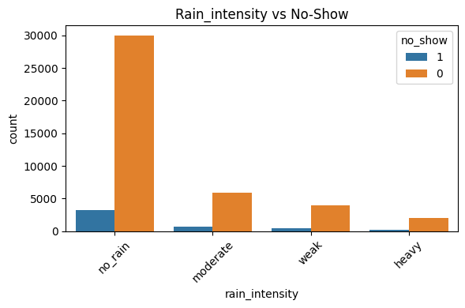
Figure 8: Heat Intensity vs No-Show
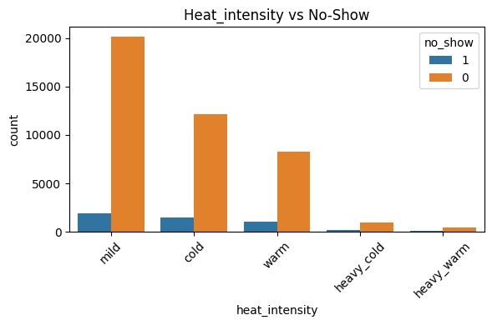
Majority of appointments are made in the temperate weather. Heavy rain or temperature days are not common and slight deviation is observable, however weather has no powerful effect in modifying the attendance but it can serve as secondary modifying factor when combined with other factors.
Pareto scatter plots point to interaction among numeric variables.
Figure 9: Pairwise Relationships (Colored by No-Show)
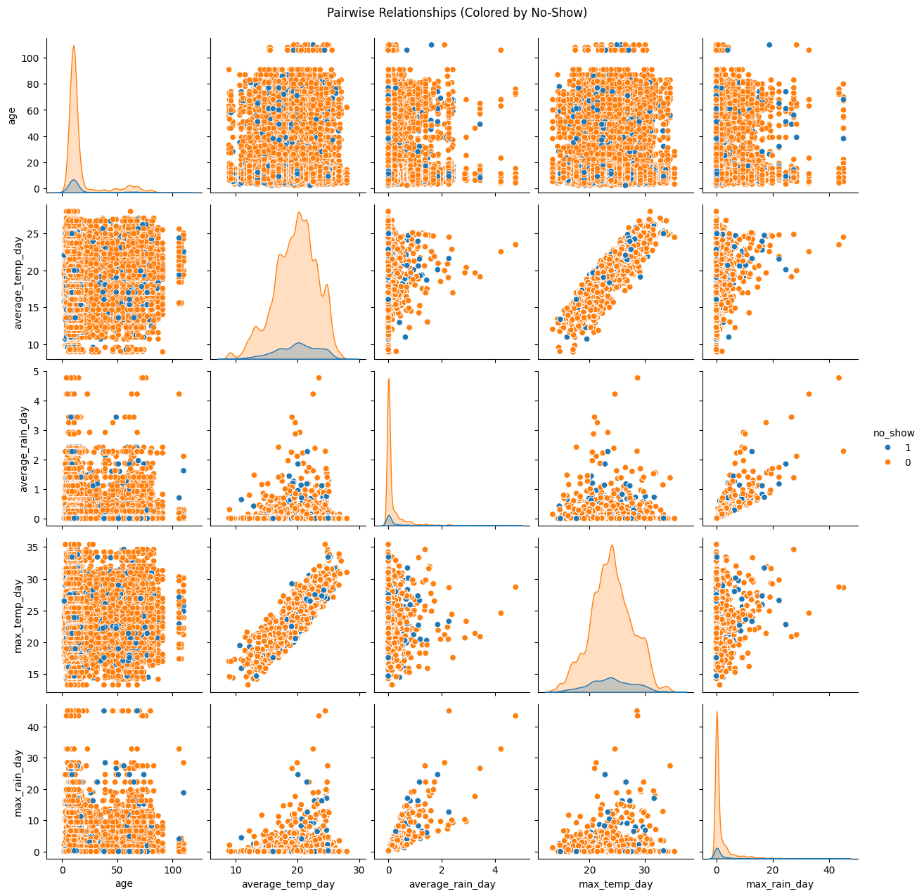
No visual distinct groups separate no-show and attended appointments, which supports the need to employ complex modelling methods that have the ability to encompass delicate structural patterns in the data.
Lastly, outlier detection was carried out as part of detecting the extreme values.
Figure 10: Outlier Detection – Boxplots for Numeric Variables
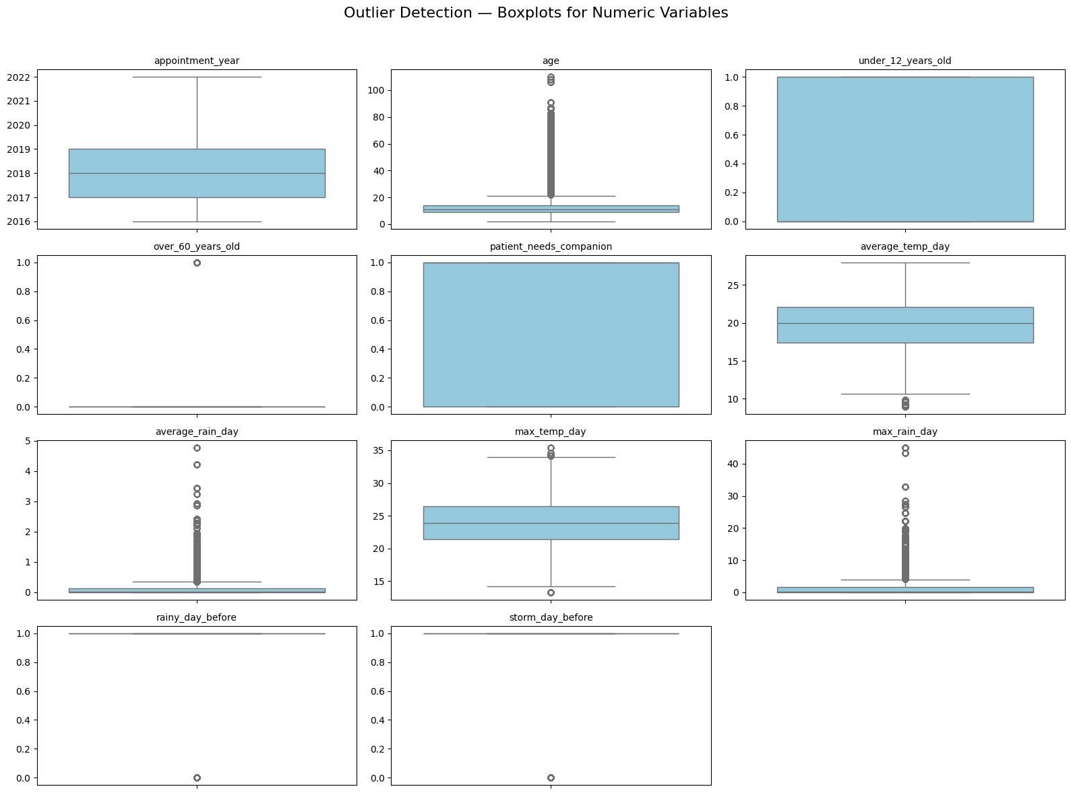
Extreme values are observed in such features as age, averagerealday and maxrainday. The presence of outliers in weather variables should be sanctioned considering natural variability whereas the outliers in age could be due to anomalies in data entry or real-life rare cases. The majority of later adopted models (e.g., XGBoost, CatBoost) are resistant to these irregularities and thus less aggressive outlier removal is necessary.
The EDA shows that the data has high demographic diversity, multidimensional characteristics of the environment, and class imbalance. Correlations are not strong enough, and it is possible that non-linear models could be a good choice. The acquired knowledge informs the preprocessing measures, model choice, and results interpretation at later phases.

Chapter 4: Results and Conclusion
The data is res

Results
The performance of four predictive models, including the Logistic Regression, the Neural Network (MLP), the CatBoost, and the tuned XGBoost, are presented with apparent variations in the efficacy to predict patient no-show. Although the performance of Logistic Regression, CatBoost, and XGBoost seem to be robust, especially in terms of accuracy and precision, the actual guide of usefulness of the models is their ability to generalise to unknown data.
Accuracy in a test set is high (0.897, 0.897, and 0.916) with Logistic Regression, XGBoost, and CatBoost, but the numbers hide the failure of the models to identify correctly missed appointments. Logistic regression and XGBoost have very low recall (0.10 and 0.09 respectively), indicating that they do not identify most of the patients that will not attend their appointments. CatBoost is better at this with a recall of 0.23, with a more balanced performance and still lacks a significant percentage of no-shows.
The Neural Network (MLP) is the lowest ranked in terms of test accuracy (0.67), but it has the highest recall (0.51) of all the models. It means that the MLP is much more attentive to identify no-shows, which means that more than half of the missed appointments are detected, which is a significant achievement, considering the clinical consequences of the failure to predict such no-shows. Despite the low level of its precision, and generating a higher number of false alarms, the MLP is more consistent with the objective of early detection of the at-risk patients.
To conclude, in the case when the main goal is to identify a maximum number of no-shows, the Neural Network is the best model in terms of recall and provides the best contribution to a practical intervention system.

Critical Discussion
The comparison of the four models reveals how the metric choice affects the model choice. Accuracy is commonly employed as a main metric in common predictive modelling exercises, but in a healthcare setting, where the objective is to forecast missed appointments, recall is more crucial than accuracy. Failure of a model to identify at-risk patients can result in unnecessary resource wastage, treatments that could take a long time, and poor efficiency in the clinic.
In this light, the Neural Network (MLP) is the most successful candidate even though it has less accuracy. Its recall 0.51 on the test set is much higher than that of CatBoost (0.23), Logistic Regression (0.10) and XGBoost (0.09). This implies that the MLP is able to proficiently recognize over fifty percent of the actual no-shows, which offers any meaningful intervention measures, including reminders, rescheduling, or support services. It is less precise, which means that there are more false positives but in this application of the test false positives are not as harmful as false negatives. In general, a clinic would rather overestimate the risk than fail to provide outreach to those who do indeed require it.
In contrast, such models as Logistic Regression and XGBoost exhibit all the typical features of overfitting. Their recall is very low on the test set, whilst their accuracy on the training set is very high. This implies that even though they were able to learn patterns existing in the training data, they were not able to generalise the patterns to newer data particularly concerning the minority class. The traditional models in question were, however, not as successful as CatBoost, which had a recall of 0.23, which was probably possible because of its advanced treatment of the categorical variables. However, this recall is still significantly lower than the one obtained by the Neural Network.
The relatively high recall rate of the MLP implies that the non-linear nature of the architecture and its ability to learn more complex patterns enable the MLP to pick up subtle behavioural cues that could be related to missing appointments. It can be enjoying the fruits of interaction, which are not the priority of tree-based models.
In general, the accuracy of the MLP is lower, which means that the model contains more noise in its predictions, but its ability to recall information is not the least impressive, which is why it is the most clinically useful model in the early risk detection. This is in line with the strategic priority, which is to minimize missed appointments, and not merely maximize the number of correct predictions.

Conclusion
The results of the evaluation indicate that tree-based models including CatBoost, Logistic Regression, and XGBoost are not effective at predicting patients who are at risk of missing the appointment, but they have high accuracy. They have low values of recall therefore being less effective in clinical intervention systems that rely on detection at an early stage.
However, the Neural Network (MLP) has the highest recall on the test data, with more than half of the true no-shows being recognized. Though this model is less accurate and less precise, it is the most useful model since its sensitivity to the minority class is significant such that when the main principle is avoidance of missed appointments, the model has the highest value. In the case of healthcare operations, recall is even more important than overall accuracy, since the ability to identify at-risk patients correctly allows taking proactive measures to decrease disruptions.
Thus, the Neural Network is the most suitable model in this particular application, and has the most practical impact at the expense of other metrics. More refinements - e.g. tuning network architecture, adding class weights, or behavioural features - might increase its precision without reducing recall.

Future Work
Further work in this project can be aimed at enhancing predictive power of the models, in particular, the recall, which is the most significant measure of identifying patients that are at risk of missing appointments. A good direction is the incorporation of cost-sensitive learning, in which case misclassifying a no-show carries a higher cost. This would promote models - in particular tree-based methods - that would give priority to minority-class detection without necessarily taking recourse to oversampling.
The enrichment of features can also be undertaken to improve it further. The addition of behavioural variables (e.g. previous no-show history, a history of SMS reminders, access to transportation, socioeconomic factors) would be effective in improving predictive strength. Patterns in repeated patient visits may also be better modeled by time-series or longitudinal modelling (e.g. with LSTM architectures) than with a static model.
The other significant direction is hyperparameter optimisation. Despite the simple tuning carried out, more complex search schemes like Bayesian optimisation can bring significant performance improvements, particularly to the Neural Network model which exhibited high recall with scope of architectural improvement.
Lastly, operational implementation considerations ought to be considered. The future research can be involved in the creation of a real-time decision-support tool warning high-risk patients and tying into the electronic scheduling systems. This would convert the predictive findings into practical interventions, which would eventually reduce the no-show rates and enhance the efficiency of healthcare resources.

Chapter 5: Legal, Ethical and Professional Issues
One of the legal matters that relate to this project is clinical decision boundary liability. When the predictions based on the no-show model are incorporated to initiate any measures like overbooking, deprioritisation of the patients or rescheduling of appointments, then accountability of bad results would be ambiguous. There can be a liability in case the automated predictions have an indirect impact on the delayed care or service denial, particularly where the model is not officially considered to be a clinical decision support system.
False positives harm the operation of the system, which is an important ethical issue. High-recall models (e.g., the Neural Network) can erroneously identify reliable patients as high-risk and remind them unnecessarily, schedule them under pressure or deprive them of their autonomy. In the long run, it can have a negative impact on patient trust and rehabilitation services.
Professionally, model interpretability and contestability are essential. Precautions against the deployment of complex models without clear explanations prohibit the option of clinicians to question predictions, professional judgment, and audit trails, especially in publicly-funded healthcare systems where accountability and justification of decisions is a compulsory requirement.

References
Abushaaban, E. and Agaoglu, M., 2022. Medical Appointment No-Show Prediction Using Machine Learning Techniques. Proceedings of the 2nd International Conference on Machine Learning and Data Science, pp. 1-6.
AlSerkal, Y.M., et al., 2025. Real-Time Analytics and AI for Managing No-Show Appointments in Primary Healthcare. Journal of Medical Systems, 49(2), pp. 1-8.
Chen, J., et al., 2021. Application of Machine Learning to Predict Patient No-Shows in Pediatric Ophthalmology. Journal of Healthcare Engineering, 2021, pp. 1-8.
Deina, C., et al., 2024. Decision Analysis Framework for Predicting No-Shows to Appointments Using Machine Learning Algorithms. BMC Health Services Research, 24(37), pp. 1-10.
Kler, R., Sharma, V., Singh, G., Ather, D., Gupta, A. and Chaudhary, N., 2024. Predicting Patient No-shows in Medical Appointments Using Demographic and Health Data. Proceedings of the 2024 International Conference on Intelligent & Innovative Practices in Engineering & Management (IIPEM), pp. 1-6.
Lovatte, M.A., Resendo, L.C. and Komati, K.S., 2024. Comparative Methods for Addressing Imbalanced Datasets in Predicting Medical Appointment No-Shows. Proceedings of the Latin American Computer Conference (CLEI), pp. 1-10.
Toffaha, K.M., Simsekler, M.C.E., Alshehhi, A. and Omar, M.A., 2024. Predicting Hospital No-Shows: Interpretable Machine Learning Models Approach. IEEE Access, 12, pp. 166058-166067.
Abushaaban, E., & Agaoglu, M. (2020). Medical appointment no-show prediction using machine learning techniques. IEEE Access, 8, 148453–148465.
Bishop, C. M. (2006). Pattern recognition and machine learning. Springer.
Breiman, L. (2001). Random forests. Machine Learning, 45(1), 5–32.
Chawla, N. V., Japkowicz, N., & Kotcz, A. (2004). Editorial: Learning from imbalanced data sets. ACM SIGKDD Explorations, 6(1), 1–6.
Chen, T., & Guestrin, C. (2016). XGBoost: A scalable tree boosting system. Proceedings of the ACM SIGKDD International Conference on Knowledge Discovery and Data Mining, 785–794.
Friedman, J. H. (2001). Greedy function approximation: A gradient boosting machine. Annals of Statistics, 29(5), 1189–1232.
Goodfellow, I., Bengio, Y., & Courville, A. (2016). Deep learning. MIT Press.
Hosmer, D. W., Lemeshow, S., & Sturdivant, R. X. (2013). Applied logistic regression (3rd ed.). Wiley.
Kler, R., Sharma, V., Singh, G., Ather, D., Gupta, A., & Chaudhary, N. (2024). Predicting patient no-shows using machine learning techniques. Proceedings of the International Conference on Intelligent & Innovative Practices in Engineering & Management (IIPEM). IEEE.
Kuhn, M., & Johnson, K. (2013). Applied predictive modeling. Springer.
Lovatte, M. A., Resendo, L. C., & Komati, K. S. (2023). Comparative methods for addressing imbalanced datasets in predicting medical appointment no-shows. Expert Systems with Applications, 215, 119342.
Prokhorenkova, L., Gusev, G., Vorobev, A., Dorogush, A. V., & Gulin, A. (2018). CatBoost: Unbiased boosting with categorical features. Advances in Neural Information Processing Systems, 31.
Toffaha, K. M., Simsekler, M. C. E., Alshehhi, A., & Omar, M. A. (2023). Predicting hospital no-shows: Interpretable machine learning models approach. Journal of Healthcare Engineering, 2023, 1–18.
Zhang, Z., & Zhao, Y. (2019). Handling class imbalance in healthcare data: A review. Journal of Biomedical Informatics, 97, 103252.
Zou, H., & Hastie, T. (2005). Regularization and variable selection via the elastic net. Journal of the Royal Statistical Society: Series B, 67(2), 301–320.

Appendices
import pandas as pd
import numpy as np
import matplotlib.pyplot as plt
import seaborn as sns

# ## Ignoring warnings

import warnings
warnings.filterwarnings("ignore")

df = pd.read_csv(r"Medical Appointments No-Show/medical-appointments-no-show-en.csv")

# ## Checking the data

df.info()

df.shape

df.head()

# # Data Cleaning

# ## Checking for null values

df.isna().sum()

# ## Checking for duplicates

print('Duplicate rows:',df.duplicated().sum())

# ## Summary Statistics

print("Numerical Summary:\n")
df.describe()

print(" Categorical Summary:\n")
df.describe(include='object')

# ## Standardize column names

df.columns = (
df.columns
.str.strip()
.str.lower()
.str.replace('-', '_')
.str.replace(' ', '_')
)

# ## Remove Duplicates

duplicates = df.duplicated().sum()
print(f"Duplicate rows: {duplicates}")
df.drop_duplicates(inplace=True)

# ## Handle Missing Values

print("Missing values before cleaning:")
print(df.isna().sum())

df.replace(['NA', 'NaN', 'None', 'nan', ' '], np.nan, inplace=True)

# ## Standardize 'no_show' column

if 'no_show' in df.columns:
df['no_show'] = df['no_show'].str.strip().str.lower()
df['no_show'] = df['no_show'].replace({'no': 0, 'yes': 1})
df['no_show'] = df['no_show'].astype('category')

# ## Cleaning categorical columns

cat_cols = df.select_dtypes(include=['object']).columns
for col in cat_cols:
df[col] = df[col].str.strip().str.lower().str.replace('-', '_')

print("Missing values after cleaning:")
print(df.isna().sum())

df.reset_index(drop=True, inplace=True)

# ## Removing columns with too many missing values

missing_percent = df.isna().mean() * 100
high_missing_cols = missing_percent[missing_percent > 50].index
print(f"Dropping columns with >50% missing: {list(high_missing_cols)}")
df.drop(columns=high_missing_cols, inplace=True)

# ## Converting object type to category type

cat_cols = df.select_dtypes(include=['object', 'category']).columns

# ## Normalizing missing values in cat_cols

for col in cat_cols:
df[col] = df[col].astype(str).fillna('unknown')
df[col] = df[col].replace(['nan', 'none', 'na', 'null', ''], 'unknown')

# ## Imputing missing values in numerical cols

num_cols = df.select_dtypes(include=[np.number]).columns
for col in num_cols:
df[col].fillna(df[col].median(), inplace=True)

print(df.isna().sum())

df.shape

# # EDA

plt.figure(figsize=(5,4))
sns.countplot(x='no_show', data=df)
plt.title("No-Show Appointment Distribution")
plt.xlabel("No Show (0 = No, 1 = Yes)")
plt.ylabel("Count")
plt.show()

# ## Numerical values bar plot

numeric_cols = df.select_dtypes(include=[np.number]).columns

df[numeric_cols].hist(bins=20, figsize=(14, 10))
plt.suptitle("Numeric Feature Distributions", fontsize=16)
plt.show()

# ## Correlation heatmap

plt.figure(figsize=(10,8))
corr = df[numeric_cols].corr(numeric_only=True)
sns.heatmap(corr, annot=True, cmap='coolwarm',vmin=-1)
plt.title("Correlation Heatmap")
plt.show()

# ## Categorical vs No show plots

invalid_genders = ['i']
df = df[~df['gender'].isin(invalid_genders)].reset_index(drop=True)

cat_cols = df.select_dtypes(include=['object', 'category']).columns

for col in cat_cols:
if col != 'no_show' and df[col].nunique() <= 12:
plt.figure(figsize=(6,4))
sns.countplot(data=df, x=col, hue='no_show')
plt.title(f"{col.capitalize()} vs No-Show")
plt.xticks(rotation=45)
plt.tight_layout()
plt.show()

important_cols = [
'age', 'average_temp_day', 'average_rain_day',
'max_temp_day', 'max_rain_day', 'rain_intensity',
'heat_intensity', 'no_show'
]
important_cols = [c for c in important_cols if c in df.columns]

if len(important_cols) > 2:
sns.pairplot(df[important_cols], hue='no_show', diag_kind='kde')
plt.suptitle("Pairwise Relationships (Colored by No-Show)", y=1.02)
plt.show()

# ## Age plot

plt.figure(figsize=(8,5))
sns.boxplot(x='no_show', y='age', data=df)
plt.title("Age Distribution by No-Show")

plt.show()

for col in ['city', 'specialty']:
if col in df.columns:
plt.figure(figsize=(10,5))
top_values = df[col].value_counts().nlargest(10).index
sns.countplot(data=df[df[col].isin(top_values)], x=col, hue='no_show')
plt.title(f"Top 10 {col.capitalize()} vs No-Show")
plt.xticks(rotation=45)
plt.tight_layout()
plt.show()

# ## Outliers

numeric_cols = df.select_dtypes(include=[np.number]).columns
plt.figure(figsize=(16, 12))
plt.suptitle("Outlier Detection — Boxplots for Numeric Variables", fontsize=16)

for i, col in enumerate(numeric_cols, 1):
plt.subplot(4, 3, i)
sns.boxplot(y=df[col], color="skyblue")
plt.title(col, fontsize=10)
plt.xlabel("")
plt.ylabel("")

plt.tight_layout(rect=[0, 0, 1, 0.96])
plt.show()

# # Model Building

from sklearn.model_selection import train_test_split
from sklearn.preprocessing import StandardScaler, OneHotEncoder
from sklearn.compose import ColumnTransformer
from sklearn.pipeline import Pipeline
from sklearn.linear_model import LogisticRegression
from sklearn.metrics import classification_report, accuracy_score

# ## Data Preprocessing

target = 'no_show'
X = df.drop(columns=[target])
y = df[target].astype(int)

cat_cols = X.select_dtypes(include=['object', 'category']).columns.tolist()
num_cols = X.select_dtypes(include=['number']).columns.tolist()

X_encoded = pd.get_dummies(X, columns=cat_cols, drop_first=True)

scaler = StandardScaler()
X_encoded[num_cols] = scaler.fit_transform(X_encoded[num_cols])

# ## Train test split

from collections import Counter
from imblearn.over_sampling import SMOTE
from sklearn.model_selection import train_test_split

X_train, X_test, y_train, y_test = train_test_split(
X_encoded, y, test_size=0.2, random_state=42, stratify=y
)

train_idx_pre_resample = X_train.index.copy()
test_idx = X_test.index.copy()

orig_train_counter = Counter(y_train)
print("Train distribution before resampling:", orig_train_counter)

sm = SMOTE(random_state=42)
X_train_res, y_train_res = sm.fit_resample(X_train, y_train)

print("Train distribution after SMOTE:", Counter(y_train_res))

X_train, y_train = X_train_res, y_train_res

total = sum(orig_train_counter.values())
class_weights = [
total / orig_train_counter.get(0, 1),
total / orig_train_counter.get(1, 1)
]
print("Class weights for CatBoost (use when creating CatBoostClassifier):", class_weights)

# ## Model training

model = LogisticRegression(max_iter=1000, random_state=42)
model.fit(X_train, y_train)

y_pred = model.predict(X_test)

print("Test Accuracy:", accuracy_score(y_test, y_pred))

from sklearn.metrics import accuracy_score, precision_recall_fscore_support, roc_auc_score, confusion_matrix

def evaluate_and_print(y_true, y_pred, y_proba=None, model_name="Model"):
acc = accuracy_score(y_true, y_pred)
prec, rec, f1, _ = precision_recall_fscore_support(y_true, y_pred, average='binary', zero_division=0)
auc = roc_auc_score(y_true, y_proba) if y_proba is not None else None
print(f"\n[{model_name}]")
print(f"Accuracy : {acc:.4f}")
print(f"Precision: {prec:.4f}")
print(f"Recall : {rec:.4f}")
print(f"F1-score : {f1:.4f}")
if auc is not None:
print(f"ROC AUC : {auc:.4f}")
print("Confusion Matrix:\n", confusion_matrix(y_true, y_pred))

X_orig = df.drop(columns=[target]).copy()

cat_cols_orig = X_orig.select_dtypes(include=['object', 'category']).columns.tolist()
cat_idx_orig = [X_orig.columns.get_loc(c) for c in cat_cols_orig]

import numpy as np
import tensorflow as tf
from tensorflow import keras
from tensorflow.keras import layers, callbacks

def build_mlp(input_dim):
model = keras.Sequential([
layers.Input(shape=(input_dim,)),
layers.Dense(256, activation='sigmoid'),
layers.Dropout(0.5),
layers.Dense(16, activation='sigmoid'),
layers.Dense(1, activation='sigmoid')
])
model.compile(
optimizer=keras.optimizers.SGD(learning_rate=0.01), # SGD optimizer, lr=0.01
loss='binary_crossentropy',
metrics=['accuracy', keras.metrics.AUC(name='auc')]
)
return model

mlp = build_mlp(X_train.shape[1])
es = callbacks.EarlyStopping(monitor='val_auc', mode='max', patience=10, restore_best_weights=True)

history = mlp.fit(
X_train, y_train,
validation_data=(X_test, y_test),
epochs=100,
batch_size=256,
callbacks=[es],
verbose=0
)

y_pred_prob_nn = mlp.predict(X_test).ravel()
y_pred_nn = (y_pred_prob_nn >= 0.5).astype(int)
evaluate_and_print(y_test, y_pred_nn, y_pred_prob_nn, model_name="Neural Network (MLP)")

from catboost import CatBoostClassifier, Pool

X_train_orig = X_orig.loc[train_idx_pre_resample]
X_test_orig = X_orig.loc[test_idx]

cat_cols_orig = X_orig.select_dtypes(include=['object', 'category']).columns.tolist()
cat_idx_orig = [X_orig.columns.get_loc(c) for c in cat_cols_orig]

train_pool = Pool(X_train_orig, y.loc[train_idx_pre_resample], cat_features=cat_idx_orig)
test_pool = Pool(X_test_orig, y.loc[test_idx], cat_features=cat_idx_orig)

cat = CatBoostClassifier(
iterations=5000,
learning_rate=0.03,
depth=6,
loss_function='Logloss',
eval_metric='AUC',
random_seed=42,
od_type='Iter',
od_wait=200,
verbose=False
)

cat.fit(train_pool, eval_set=test_pool, use_best_model=True)

y_pred_prob_cat = cat.predict_proba(test_pool)[:, 1]
y_pred_cat = (y_pred_prob_cat >= 0.5).astype(int)
evaluate_and_print(y_test, y_pred_cat, y_pred_prob_cat, model_name="CatBoost")

from xgboost import XGBClassifier

xgb = XGBClassifier(
n_estimators=2000,
learning_rate=0.02,
max_depth=6,
subsample=0.8,
colsample_bytree=0.8,
reg_lambda=1.0,
objective='binary:logistic',
eval_metric='auc',
random_state=42,
n_jobs=-1
)

xgb.fit(
X_train, y_train,
eval_set=[(X_test, y_test)],
)

y_pred_prob_xgb = xgb.predict_proba(X_test)[:, 1]
y_pred_xgb = (y_pred_prob_xgb >= 0.5).astype(int)
evaluate_and_print(y_test, y_pred_xgb, y_pred_prob_xgb, model_name="XGBoost")

# --- Hyperparameter tuning for XGBoost (reduced grid) ---
from sklearn.model_selection import GridSearchCV
from xgboost import XGBClassifier

param_grid = {
'n_estimators': [500, 1000],
'learning_rate': [0.01, 0.05],
'max_depth': [4, 6],
'subsample': [0.8],
'colsample_bytree': [0.8]
}

xgb_tune = XGBClassifier(
objective='binary:logistic',
eval_metric='auc',
random_state=42,
n_jobs=-1
)

grid_search = GridSearchCV(
estimator=xgb_tune,
param_grid=param_grid,
scoring='accuracy',
cv=3,
verbose=2
)
grid_search.fit(X_train, y_train)

best_xgb = grid_search.best_estimator_
y_pred_xgb = best_xgb.predict(X_test)

# --- Collect model accuracies and create a DataFrame ---
accuracies = {}
accuracies['Logistic Regression'] = accuracy_score(y_test, y_pred)
accuracies['Neural Network (MLP)'] = accuracy_score(y_test, y_pred_nn)
accuracies['CatBoost'] = accuracy_score(y_test, y_pred_cat)
accuracies['XGBoost (Tuned)'] = accuracy_score(y_test, y_pred_xgb)
acc_df = pd.DataFrame(list(accuracies.items()), columns=['Model', 'Accuracy'])
print(acc_df)
acc_df

# --- Track training metrics (accuracy, precision, recall, f1) for each model ---
from sklearn.metrics import accuracy_score, precision_score, recall_score, f1_score

# CatBoost train predictions (probability-based, on original train_pool)
y_pred_prob_cat_train = cat.predict_proba(train_pool)[:, 1]
y_pred_cat_train = (y_pred_prob_cat_train >= 0.5).astype(int)

# Prepare predictions for train set for each model
train_preds = {
'CatBoost': y_pred_cat_train,
'Logistic Regression': model.predict(X_train),
'Neural Network (MLP)': (mlp.predict(X_train).ravel() >= 0.5).astype(int),
'XGBoost (Tuned)': best_xgb.predict(X_train)
}

# Prepare true labels for each model (CatBoost uses pre-resample, others use y_train)
train_true = {
'CatBoost': y.loc[train_idx_pre_resample],
'Logistic Regression': y_train,
'Neural Network (MLP)': y_train,
'XGBoost (Tuned)': y_train
}

# Calculate metrics for train set
train_metrics = {'Model': [], 'Accuracy': [], 'Precision': [], 'Recall': [], 'F1-score': []}
for model in train_preds:
preds = train_preds[model]
true = train_true[model]
train_metrics['Model'].append(model)
train_metrics['Accuracy'].append(accuracy_score(true, preds))
train_metrics['Precision'].append(precision_score(true, preds))
train_metrics['Recall'].append(recall_score(true, preds))
train_metrics['F1-score'].append(f1_score(true, preds))

train_metrics_df = pd.DataFrame(train_metrics)
print('Train Metrics Table:')
print(train_metrics_df)

train_metrics_df

# --- Calculate and display test metrics (accuracy, precision, recall, f1) for each model ---
from sklearn.metrics import accuracy_score, precision_score, recall_score, f1_score

# Test predictions for each model
test_preds = {
'Logistic Regression': y_pred,
'Neural Network (MLP)': y_pred_nn,
'CatBoost': y_pred_cat,
'XGBoost (Tuned)': y_pred_xgb
}

# Calculate metrics for test set
test_metrics = {'Model': [], 'Accuracy': [], 'Precision': [], 'Recall': [], 'F1-score': []}
for model in test_preds:
preds = test_preds[model]
test_metrics['Model'].append(model)
test_metrics['Accuracy'].append(accuracy_score(y_test, preds))
test_metrics['Precision'].append(precision_score(y_test, preds))
test_metrics['Recall'].append(recall_score(y_test, preds))
test_metrics['F1-score'].append(f1_score(y_test, preds))

test_metrics_df = pd.DataFrame(test_metrics)
print('Test Metrics Table:')
# print(test_metrics_df)
test_metrics_df

# Train RandomForestClassifier with balanced subsample and specified hyperparameters
from sklearn.ensemble import RandomForestClassifier
from sklearn.metrics import classification_report

rfc = RandomForestClassifier(
class_weight='balanced_subsample',
n_estimators=700,
max_depth=10,
min_samples_split=10,
min_samples_leaf=4,
random_state=42,
n_jobs=-1
)

rfc.fit(X_train, y_train)
y_pred_rfc = rfc.predict(X_test)

print("Random Forest Classification Report:")
print(classification_report(y_test, y_pred_rfc))

